
 Velammal College of Engineering andTechnology,
Madurai – 625 009(An Autonomous Institution)
Department of Computer Science and Engineering
Academic Year: 2023 - 2024 (EVEN Semester)
B.ECSE-IIYEAR-IV SEMESTER
21CS210 – Database Management Systems Laboratory
Mini Project
STUDENT DATABASE MANAGEMENT SYSTEMS
SUBMITTED BY,
Team member 1:ABITHA SRI G(22CSEC03)
Team member 2: MUTHIESWARI S(22CSEC15)
Mark Splitup
S.No. | Criteria | Maximum Marks | Marks Obtained
1. | Application Complexity | 05
2. | Database Design | 20
3. | Proper Documentation | 10
4. | Frontend Design | 05
5. | Presentation | 05
6. | On time submission | 05
 | Total | 50

Course Skilled Course In-charge
Mrs. Arunasakthi Dr. A.M.Rajeswari
Mrs. R.Niranjana Associate Professor,
Assistant Professor,CSE CSE

TABLE OF CONTENT
S.No. | Title | Page No.
1. | Introduction
2. | Application User
3. | Functional Overview
4. | Detailed Functional Requirement
5. | Software and Hardware Requirement
6. | Performance Requirement
7. | Validation Criteria
8. | Entities and Relationships
9. | Entities and Relationship Diagram
10. | Functional Dependencies and Normalization
11. | Data Dictionaries
12. | Database Creation and listing using MySQL
13. | Establishing database connectivity through PHP
14. | Conclusion
15. | References

1) INTRODUCTION
This project aims to computerize the operations of the student database of an institution. Features include managing student details and the continuous assessment test marks of the students.

2) APPLICATION USERS
The users of the system are the teaching staff, students and their parents. Teaching staff can update the mark and add students.All the users can view the details of the students like test marks and assignment mark details of the students.

3) FUNCTIONS OVERVIEW
The following functionality will be supported by the student database management system.
- Student name updating and view.
- Marks updating and view.

4) DETAILED FUNCTION REQUIREMENTS
4.1 Attendance updating and view.
Teaching staff records the attendance detail of the students for the subjects handled by them. In case of default, attendance can be updated by the teaching staff by considering the allowable on duty leave. Based on the attendance percentage, the students are allowed to take the semester examinations. All the users can view the details of the attendance.
Attendance reports like monthly report, cumulative report and overall report are generated.
4.2 Marks updating and view.
Teaching staff records the mark details scored by the students in their subjects. The marks include continuous assessment tests and assignments. All the users can view the details of the attendance and marks scored by the student in the tests and the assignments.
Report like the marks for individual test, assignments marks for individual subjects, overall marks scored by the students for every test, and overall internal marks obtained by the students, their results and their Grade (CGPA) in every subject are generated.

5) SOFTWARE AND HARDWARE REQUIREMENTS
Front end Tool : visual studio
ServerSide programming : php
Backend DataBase : XAMPP

6) PERFORMANCE REQUIREMENTS
Capacity Requirements : 5 users (student/parent/staff)
Sample Data Base Size : 10 to 20 tuples
Response time | : 1micro seconds
Through put | : Average transaction per minute may be 3

7) VALIDATION CRITERIA
We will load the database with sample data of 5 Students, 5 Staff, 5 Subjects, 3 Tests and Assignment for testing. We will test the system by finding the grade for the student.

8) ENTITIES AND RELATIONSHIP

8.1 Entities
i)admin
ii)student
iii)faculty

8.2 Relationships
i) Login to
ii) Can add
iii) Enter mark
iv) Can check

9) ER DIAGRAM
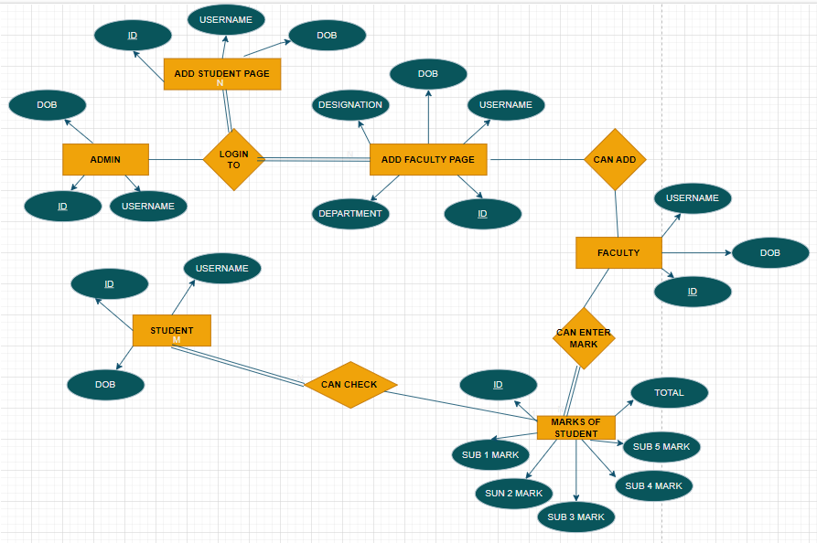

10) FUNCTIONAL DEPENDENCIES AND NORMALIZATION
The initial relational schema from the ER diagram.

10.1 Schema

Admin(username,ID,DOB)
faculty(username,ID,DOB)
Student(username,ID,DOB)

10.2 Functional Dependencies

S .NO | Relation Name | Set of FD | BCNF Checking
1 | Student | 1. Username → ID  2. ID → Dob | the only candidate key is ID, which is also a superkey satisfying both functional dependencies. Therefore, to ensure BCNF compliance, we consider both FDs. So, the relation would be in BCNF..
2 | Faculty | 1. Username → ID  2. ID → Dob, Designation, Department | Since both FDs have a candidate key (Username and ID), and ID is a superkey satisfying both FDs, we would consider both FDs to ensure BCNF compliance. So, the relation would be in BCNF
3 | Student | 1. Username → ID  2. ID → Dob | Then, since both FDs have a candidate key (Username and ID), and ID is a superkey satisfying both FDs, we would consider both FDs to ensure BCNF compliance. So, the relation would be in BCNF
4 | Add Student page | 1. Username → ID  2. ID → Dob | the only candidate key is ID, which is also a superkey satisfying both functional dependencies. Therefore, to ensure BCNF compliance, we consider both FDs. So, the relation would be in BCNF.
5 | Add Faculty Page | 1. Username → ID  2. ID → Dob, Designation, Department | Both Username and ID serve as candidate keys, and ID is a superkey satisfying both functional dependencies. Therefore, to ensure BCNF compliance, we consider both FDs. So, the relation would be in BCNF.
6 | Faculty | 1. Username → ID  2. ID → Dob | Since both FDs have a candidate key (Username and ID), and ID is a superkey satisfying both FDs, we would consider both FDs to ensure BCNF compliance. So, the relation would be in BCNF.
7 | Attendance | 1. Student-id, Date → Status | Here, the combination of {Student-id, Date} serves as a candidate key, ensuring uniqueness of attendance records. Since this candidate key satisfies the functional dependency, the relation is already in BCNF.
8 | Marks of student | 1. ID → Mark1, Mark2, Mark3, Mark4, Mark5, Total | Here, the only candidate key is ID, which is also a superkey satisfying the functional dependency. Therefore, to ensure BCNF compliance, we consider the given FD. So, the relation would be in BCNF.

11) Data Dictionary
ADMIN
ATTRIBUTES | DATA TYPE | KEY | REMARKS
USERNAME | VARCHAR | - | NAME OF THE ADMIN
ID | INT | PRIMARY KEY | ADMIN ID
DOB | DATE | - | DATE OF BIRTH OF ADMIN
FACULTY
ATTRIBUTES | DATA TYPE | KEY | REMARKS
USERNAME | VARCHAR | - | NAME OF THE FACULTY
ID | INT | PRIMARY KEY | FACULTY ID
DOB | DATE | - | DATE OF BIRTH OF FACULTY

STUDENT
ATTRIBUTES | DATA TYPE | KEY | REMARKS
USERNAME | VARCHAR | - | NAME OF THE ADMIN
ID | INT | PRIMARY KEY | STUDENT ID
DOB | DATE | - | DATE OF BIRTH OF STUDENT

ATTENDANCE
ATTRIBUTES | DATA TYPE | KEY | REMARKS
STATUS | VARCHAR | - | PRESENT(OR) ABSENT
STUDENT_ID | INT | PRIMARY KEY | STUDENT ID
DATE | DATE | - | ATTENDANCE DATE OF STUDENT

12) DATABASE CREATION

1) Student table
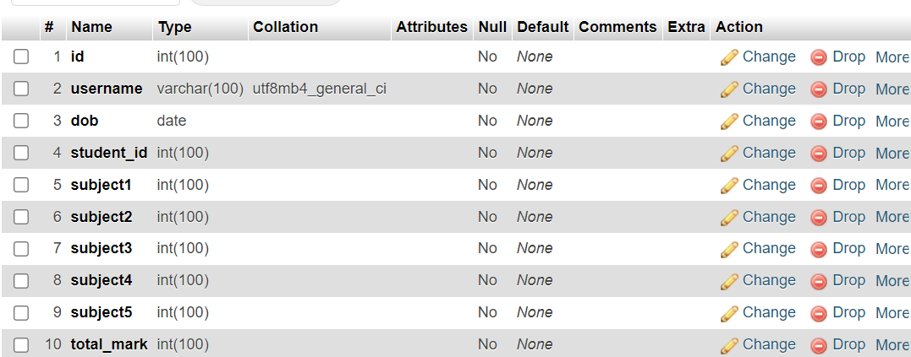

2)Faculty table
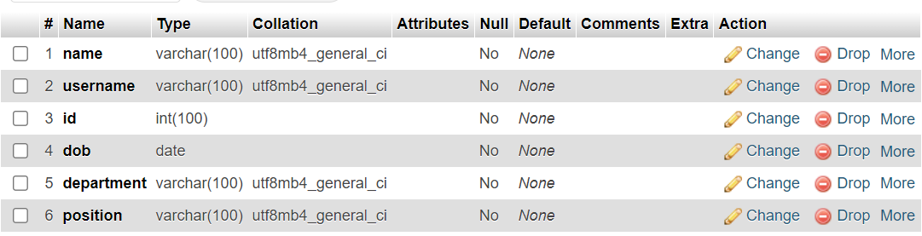
3) Attendance table
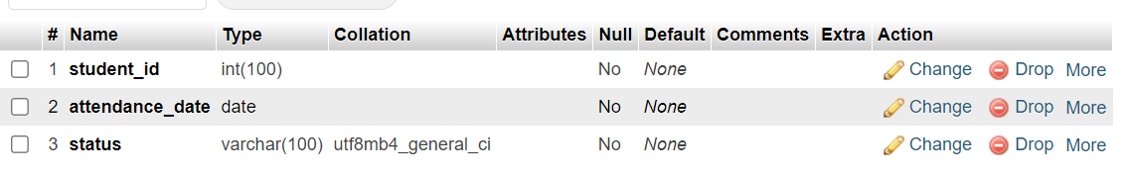
13) FUNCTIONALTIES-CODING

Index.html
<!DOCTYPE html>
<html lang="en">
<head>
<meta charset="UTF-8">
<meta name="viewport" content="width=device-width, initial-scale=1.0">
<title>Velammal College of Engineering and Technology - Login</title>
<link rel="stylesheet" href="style.css">
</head>
<body>
<center>
<h1>Velammal College of Engineering and Technology - Login</h1>
<div class="rotate-image-container">
<img src="vcet.jpg" alt="Rotating Image">
</div>
<div class="login-container">
<h2>Login</h2>
<form action="authenticate.php" method="post">
<select name="user_type" required>
<option value="" disabled selected>Select user type</option>
<option value="student">Student</option>
<option value="faculty">Faculty</option>
<option value="admin">Admin</option>
</select>
<input type="text" name="username" placeholder="Username" required>
<input type="date" name="dob" required>
<input type="text" name="id" placeholder="ID" required>
<button type="submit">Login</button>
</form>
</div>
</center>
</body>
</html>

Authenticate.php

<!DOCTYPE html>
<html lang="en">
<head>
<meta charset="UTF-8">
<meta name="viewport" content="width=device-width, initial-scale=1.0">
<link rel="stylesheet" href="style1.css">
<?php
session_start();
$servername = "localhost";
$username = "root";
$password = "";
$database_name = "database_stu";
$conn = new mysqli($servername, $username, $password, $database_name);
if ($conn->connect_error) {
die("Connection failed: " . $conn->connect_error);
}
$user_type = $_POST['user_type'];
$username = $_POST['username'];
$id = $_POST['id'];
$dob = $_POST['dob'];
if ($user_type == 'student') {
$sql = "SELECT * FROM students WHERE username = '$username' AND id = '$id' AND dob = '$dob'";
$result = $conn->query($sql);

if ($result->num_rows > 0) {
// Student exists, set session variable and redirect to student page
$row = $result->fetch_assoc();
$_SESSION['student_id'] = $row['id'];
echo "<h2>Student Information</h2>";
echo "Student ID: " . $row["id"]. "<br>";
echo "Student Name: " . $row["username"]. "<br>";
echo "Date of Birth: " . $row["dob"]. "<br>";
echo "<h2>Marks</h2>";
echo "Subject 1 Mark: " . $row["subject1"]. "<br>";
echo "Subject 2 Mark: " . $row["subject2"]. "<br>";
echo "Subject 3 Mark: " . $row["subject3"]. "<br>";
echo "Subject 4 Mark: " . $row["subject4"]. "<br>";
echo "Subject 5 Mark: " . $row["subject5"]. "<br>";
echo "Total Mark: " . $row["total_mark"]. "<br>";
exit();
} else {
header("Location: index.html?error=invalid_student");
exit();
}
} elseif ($user_type == 'faculty') {
$sql = "SELECT * FROM faculty WHERE username = '$username' AND id = '$id' AND dob = '$dob'";
$result = $conn->query($sql);

if ($result->num_rows > 0) {
header("Location: faculty.php");
exit();
} else {
header("Location: index.html?error=invalid_faculty");
exit();
}
} elseif ($user_type == 'admin') {
$admin_username = 'admin';
$admin_id = '123';
$admin_dob = '1990-01-01';
if ($username === $admin_username && $id === $admin_id && $dob === $admin_dob) {
header("Location: add_faculty.php");
exit();
} else {
header("Location: index.php?error=invalid_admin");
exit();
}
}
$conn->close();
?>
Add_student.php

<!DOCTYPE html>
<html lang="en">
<head>
<meta charset="UTF-8">
<meta name="viewport" content="width=device-width, initial-scale=1.0">
<title>Add Student</title>
<link rel="stylesheet" href="style1.css">
</head>
<body>
<h2>Add Student</h2>
<div class="form-container">
<form action="add_student_process.php" method="post">
<input type="text" name="username" placeholder="Username" required><br>
<input type="text" name="id" placeholder="ID" required><br>
<input type="date" name="dob" required><br>
<button type="submit">Add Student</button>
</form>
</div>
</body>
</html>

Add_student_process.php

<?php
$servername = "localhost";
$username = "root";
$password = "";
$database_name = "database_stu";
$conn = new mysqli($servername, $username, $password, $database_name);
if ($conn->connect_error) {
die("Connection failed: " . $conn->connect_error);
}
$username = $_POST['username'];
$id = $_POST['id'];
$dob = $_POST['dob'];
$sql = "INSERT INTO students (username, id, dob) VALUES ('$username', '$id', '$dob')";

if ($conn->query($sql) === TRUE) {
echo "Student added successfully";
} else {
echo "Error: " . $sql . "<br>" . $conn->error;
}
$conn->close();
?>

Delete_student.php
<?php
$servername = "localhost";
$username = "root";
$password = "";
$database_name = "database_stu";
$conn = new mysqli($servername, $username, $password, $database_name);
if ($conn->connect_error) {
die("Connection failed: " . $conn->connect_error);
}
if(isset($_GET['id'])) {
$student_id = $_GET['id'];
$sql = "DELETE FROM students WHERE id=$student_id";
if ($conn->query($sql) === TRUE) {
echo "Student deleted successfully.";
} else {
echo "Error deleting student: " . $conn->error;
}
} else {
echo "Student ID not provided.";
}
$conn->close();
?>

Mark_entry.php

<!DOCTYPE html>
<html lang="en">
<head>
<meta charset="UTF-8">
<meta name="viewport" content="width=device-width, initial-scale=1.0">
<title>Mark Entry</title>
<link rel="stylesheet" href="style1.css">
</head>
<body>
<h2>Mark Entry</h2>
<div class="form-container">
<form action="mark_entry_process.php" method="post">
<input type="text" name="student_id" placeholder="Student ID" required><br>
<input type="number" name="subject1" placeholder="Subject 1 Mark" required><br>
<input type="number" name="subject2" placeholder="Subject 2 Mark" required><br>
<input type="number" name="subject3" placeholder="Subject 3 Mark" required><br>
<input type="number" name="subject4" placeholder="Subject 4 Mark" required><br>
<input type="number" name="subject5" placeholder="Subject 5 Mark" required><br>
<button type="submit">Submit Marks</button>
</form>
</div>
</body>
</html>

Mark_entry_process.php

<?php
$servername = "localhost";
$username = "root";
$password = "";
$database_name = "database_stu";
$conn = new mysqli($servername, $username, $password, $database_name);
if ($conn->connect_error) {
die("Connection failed: " . $conn->connect_error);
}
$student_id = $_POST['student_id'];
$subject1 = $_POST['subject1'];
$subject2 = $_POST['subject2'];
$subject3 = $_POST['subject3'];
$subject4 = $_POST['subject4'];
$subject5 = $_POST['subject5'];
$total_mark = $subject1 + $subject2 + $subject3 + $subject4 + $subject5;
$sql = "UPDATE students SET student_id='$student_id',subject1 = '$subject1', subject2 = '$subject2', subject3 = '$subject3',
subject4 = '$subject4', subject5 = '$subject5', total_mark = '$total_mark' WHERE id = '$student_id'";
if ($conn->query($sql) === TRUE) {
echo "Marks updated successfully";
} else {
echo "Error: " . $sql . "<br>" . $conn->error;
}
$conn->close();
?>

Add_faculty.php

<!DOCTYPE html>
<html lang="en">
<head>
<meta charset="UTF-8">
<meta name="viewport" content="width=device-width, initial-scale=1.0">
<title>Add Faculty</title>
<link rel="stylesheet" href="style1.css">
</head>
<body>
<center>
<h1>Add Faculty</h1>
<div class="add-faculty-container">
<h2>Fill in the details</h2>
<form action="process_faculty.php" method="post">
<input type="text" name="name" placeholder="Name" required><br>
<input type="text" name="username" placeholder="Username" required><br>
<input type="text" name="id" placeholder="ID" required><br>
<input type="date" name="dob" required><br>
<input type="text" name="department" placeholder="Department" required><br>
<input type="text" name="position" placeholder="Position" required><br>
<button type="submit">Add Faculty</button>
</form>
</div>
</center>
</body>
</html>

Process_faculty.php

<!DOCTYPE html>
<html lang="en">
<head>
<meta charset="UTF-8">
<meta name="viewport" content="width=device-width, initial-scale=1.0">
<link rel="stylesheet" href="style1.css"><?php
// Database connection
$servername = "localhost";
$username = "root";
$password = "";
$database_name = "database_stu";
$conn = new mysqli($servername, $username, $password, $database_name);
if ($conn->connect_error) {
die("Connection failed: " . $conn->connect_error);
}
$name = $_POST['name'];
$username = $_POST['username'];
$id = $_POST['id'];
$dob = $_POST['dob'];
$department = $_POST['department'];
$position = $_POST['position'];
$sql = "INSERT INTO faculty (name, username, id, dob, department, position)
VALUES ('$name', '$username', '$id', '$dob', '$department', '$position')";
if ($conn->query($sql) === TRUE) {
// Display success message
echo "<div style='text-align: center;'>";
echo "<h2 style='color: green;'>Faculty added successfully!</h2>";
echo "<p><strong>Name:</strong> $name</p>";
echo "<p><strong>Username:</strong> $username</p>";
echo "<p><strong>ID:</strong> $id</p>";
echo "<p><strong>Date of Birth:</strong> $dob</p>";
echo "<p><strong>Department:</strong> $department</p>";
echo "<p><strong>Position:</strong> $position</p>";
echo "<button style='margin-top: 20px;' onclick=\"window.location.href='index.html'\">Return to Login</button>";
echo "</div>";
} else {
echo "Error: " . $sql . "<br>" . $conn->error;
}
$conn->close();
?>
</html>

Student.php

<?php
session_start();
if(isset($_SESSION['username'])) {
$servername = "localhost";
$username = "root";
$password = "";
$database_name = "database_stu";
$conn = new mysqli($servername, $username, $password, $database_name);
if ($conn->connect_error) {
die("Connection failed: " . $conn->connect_error);
}
$username = $_SESSION['username'];
$sql = "SELECT * FROM students WHERE username = '$username'";
$result = $conn->query($sql);
if ($result->num_rows > 0) {
// Output student information and marks
$row = $result->fetch_assoc();
echo "<h2>Student Information</h2>";
echo "Student ID: " . $row["id"]. "<br>";
echo "Student Name: " . $row["username"]. "<br>";
echo "Date of Birth: " . $row["dob"]. "<br>";
echo "<h2>Marks</h2>";
echo "Subject 1 Mark: " . $row["subject1"]. "<br>";
echo "Subject 2 Mark: " . $row["subject2"]. "<br>";
echo "Subject 3 Mark: " . $row["subject3"]. "<br>";
echo "Subject 4 Mark: " . $row["subject4"]. "<br>";
echo "Subject 5 Mark: " . $row["subject5"]. "<br>";
echo "Total Mark: " . $row["total_mark"]. "<br>";
} else {
echo "No data found for the student.";
}
$conn->close();
} else {
header("Location: index.php");
exit();
}
?>
Submit_attendance.php

<?php
// Database connection
$servername = "localhost";
$username = "root";
$password = "";
$database_name = "database_stu";
$conn = new mysqli($servername, $username, $password, $database_name);
if ($conn->connect_error) {
die("Connection failed: " . $conn->connect_error);
}
if ($_SERVER["REQUEST_METHOD"] == "POST") {
$student_id = $_POST["student_id"];
$attendance_status = $_POST["attendance"];
$sql = "INSERT INTO attendance (student_id, attendance_date, status) VALUES (?, CURDATE(), ?)";
$stmt = $conn->prepare($sql);
$stmt->bind_param("is", $student_id, $attendance_status);

if ($stmt->execute()) {
echo "Attendance submitted successfully.";
} else {
echo "Error: " . $sql . "<br>" . $conn->error;
}
}

// Close statement and connection
$stmt->close();
$conn->close();
?>
Style.css
body {
font-family: Arial, sans-serif;
margin: 0;
padding: 0;
background-color:mintcream;
}
.rotate-image-container {
margin-top: 10px;
display: inline-block;
width: 150px;
height: 150px;
}
.rotate-image-container img {
animation: rotateImage 5s linear infinite;
}
@keyframes rotateImage {
0% {
transform: rotateY(0deg);
}
100% {
transform: rotateY(360deg);
}
50% {
transform: rotateY(180deg);
}
}
.login-container input[type="text"],
.login-container input[type="date"],
.login-container button {
width: 100%;
margin-bottom: 15px;
padding: 12px;
box-sizing: border-box;
border-radius: 8px;
font-size: 16px; /* Increase font size */
}
nav ul li {
display: inline;
}
nav ul li a {
display: block;
padding: 10px 20px;
color: #fff;
text-decoration: none;
}
.content {
padding: 20px;
}
h1 {
color: brown;
text-align: center;
font-size: 36px; /* Adjust the font size as needed */
text-shadow:
2px 2px 4px rgba(255, 165, 0, 0.5),
4px 4px 6px rgba(255, 165, 0, 0.3),
6px 6px 8px rgba(255, 165, 0, 0.2);
}

14) BACKEND DESIGNING

Faculty database

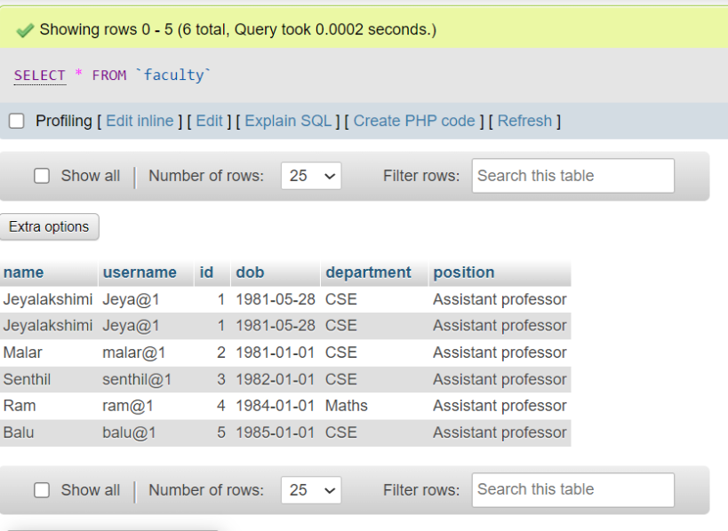

Students database

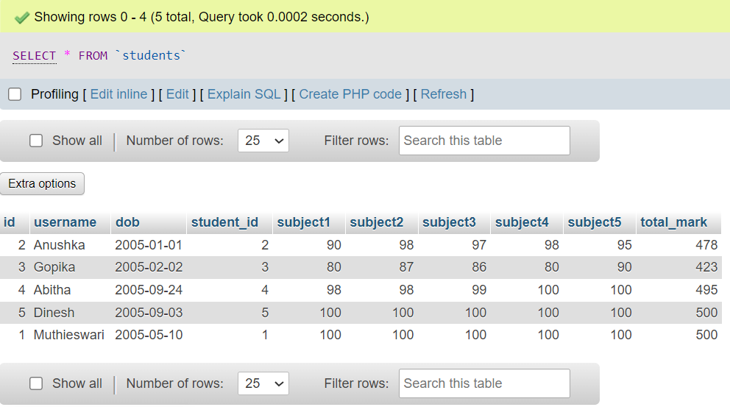

Attendance database
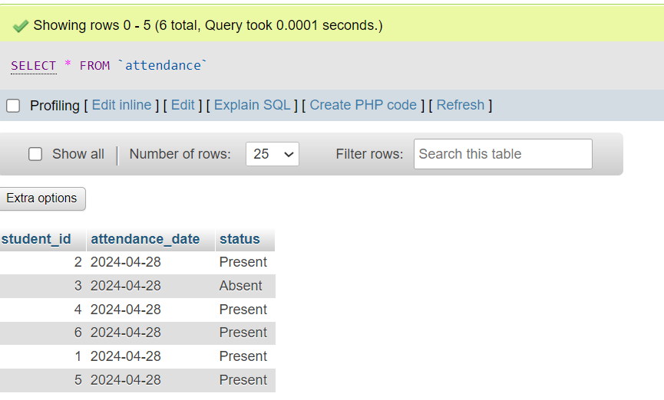

14) FRONTEND DESIGNING

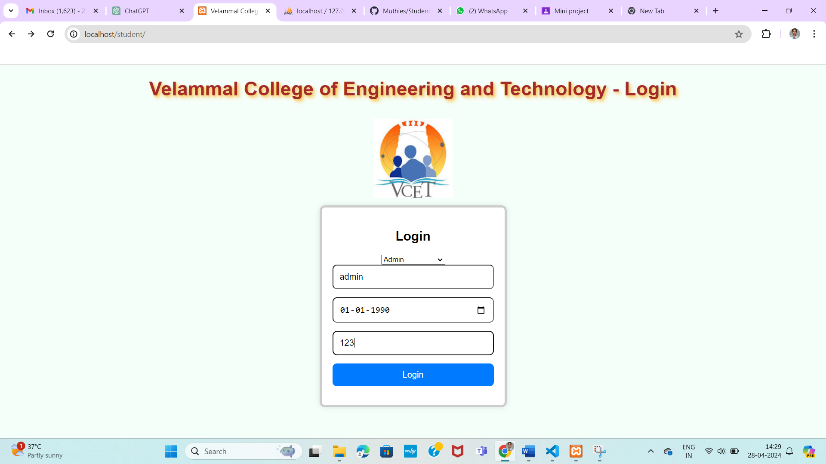

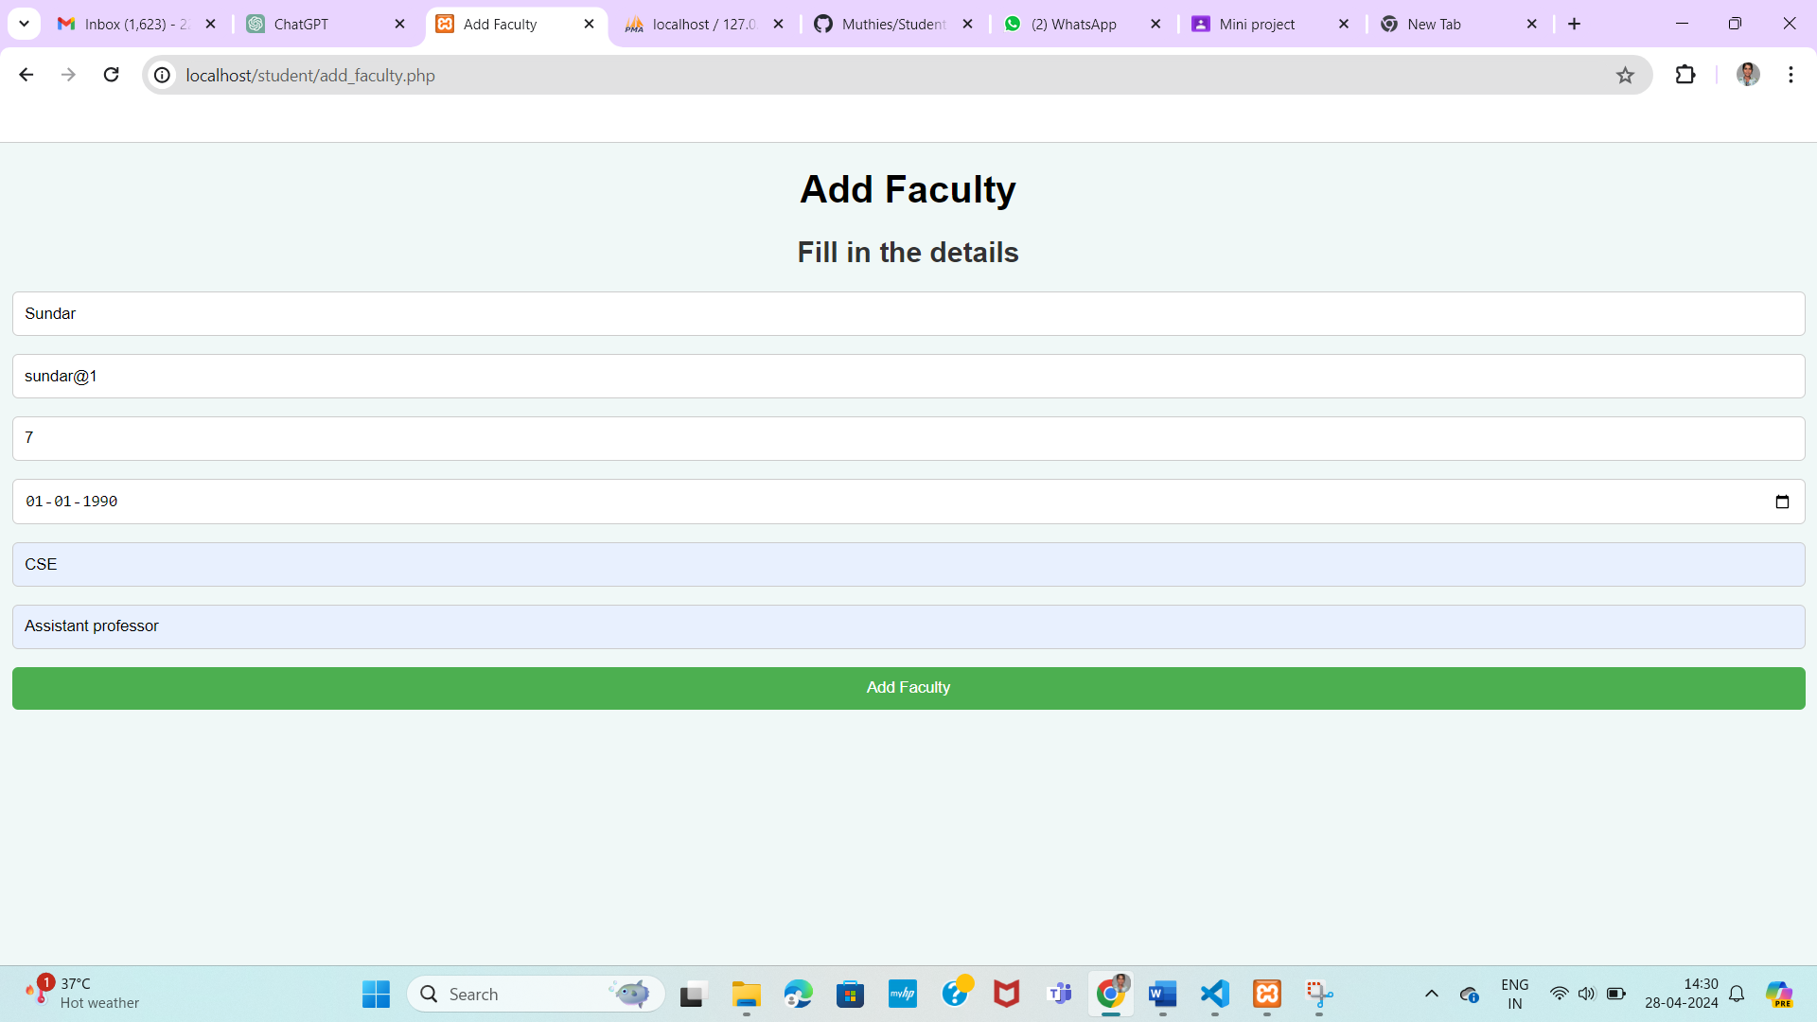

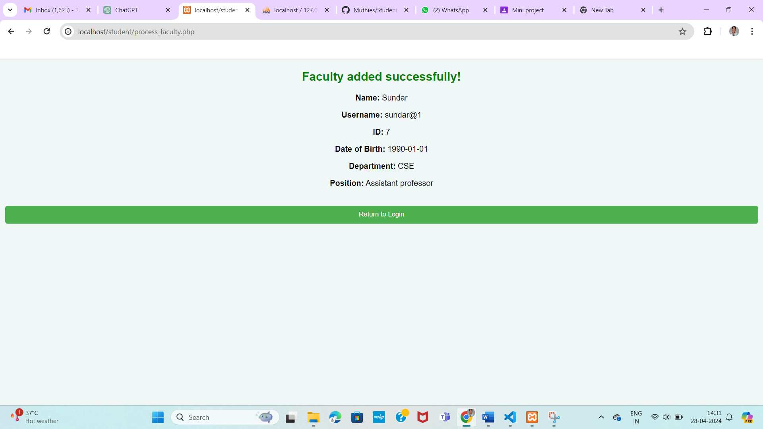

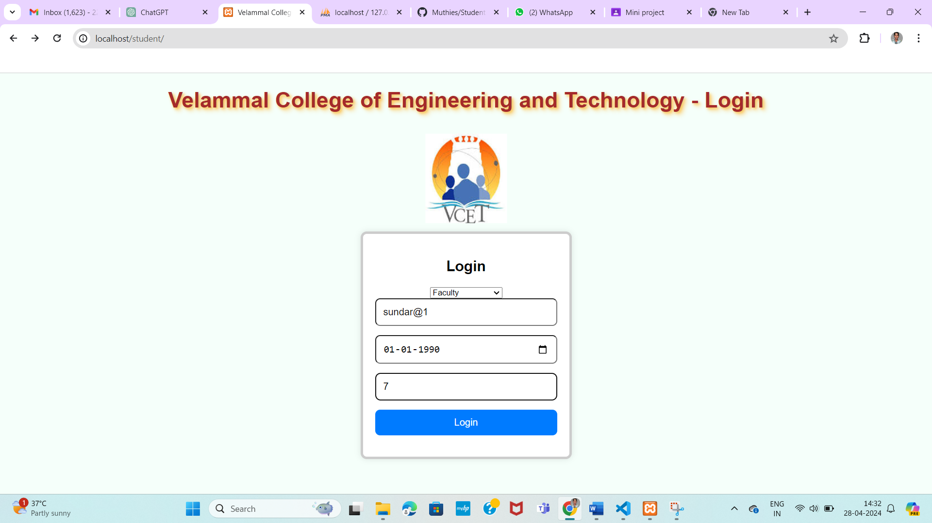

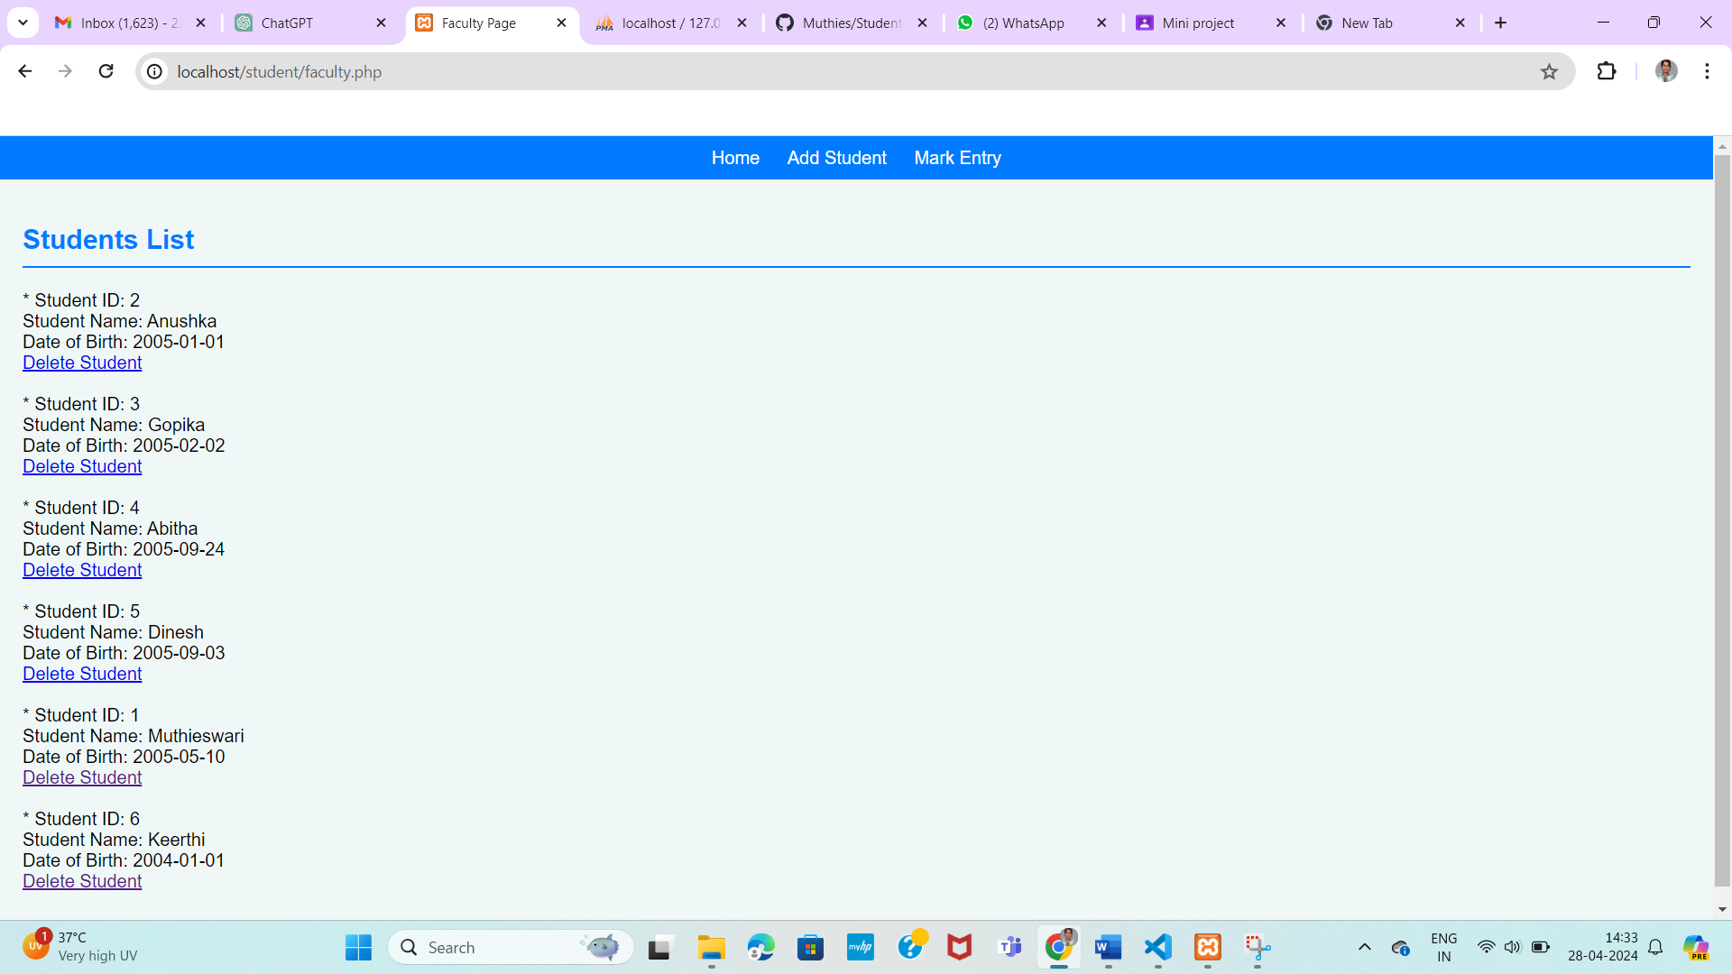


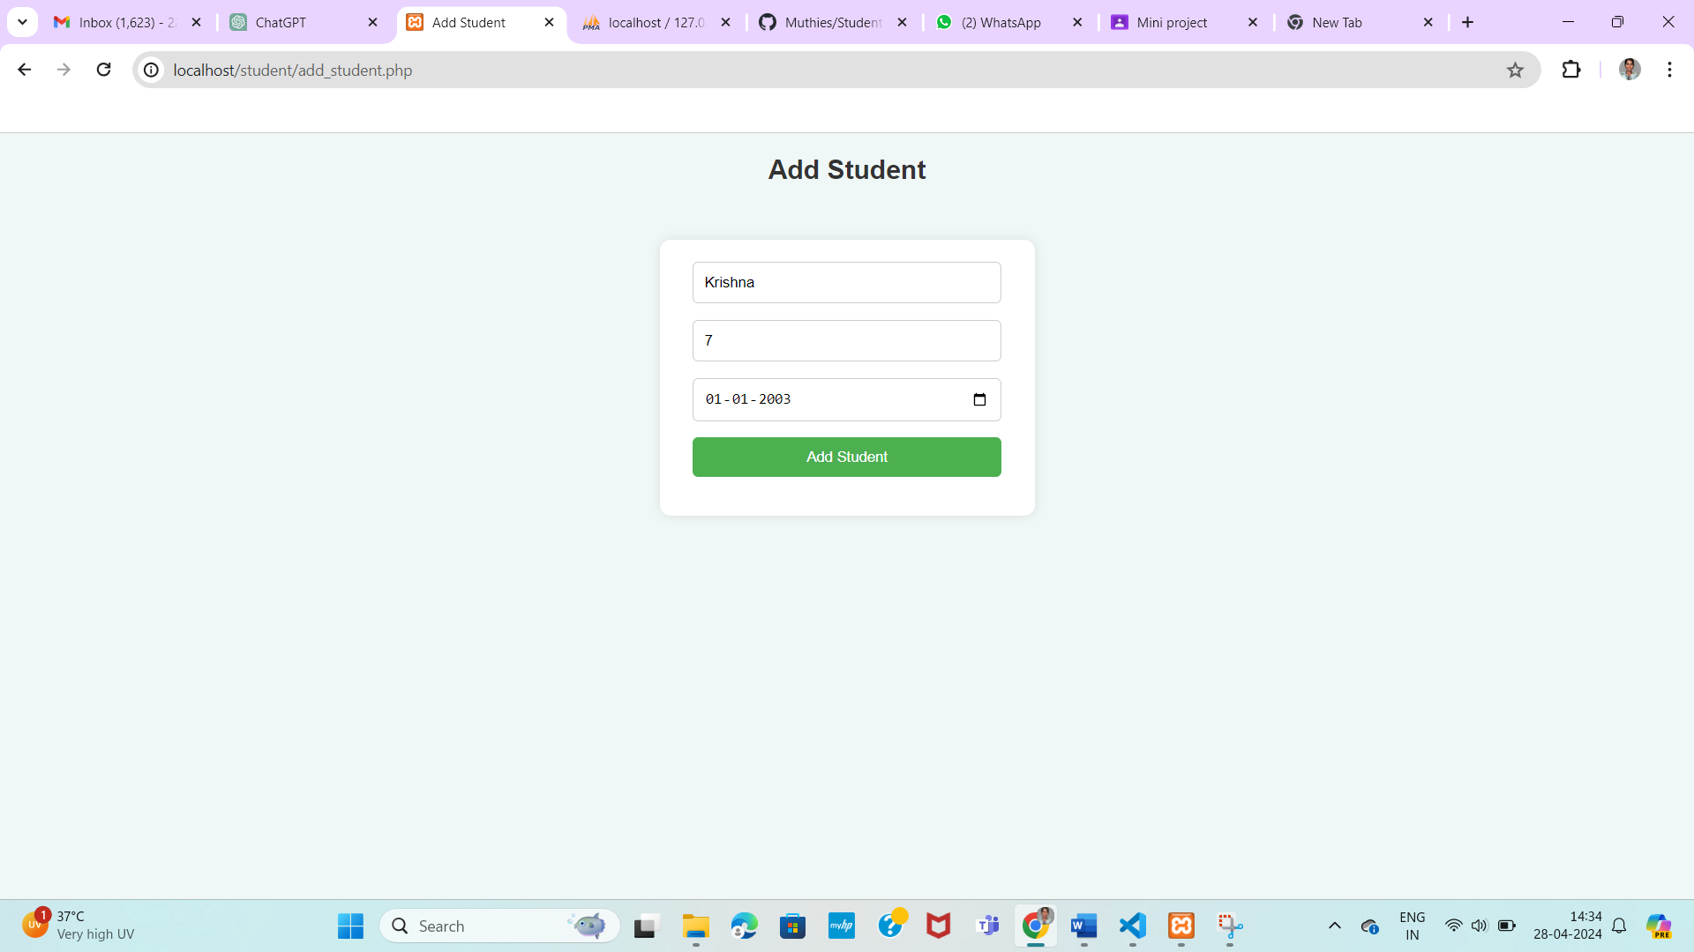
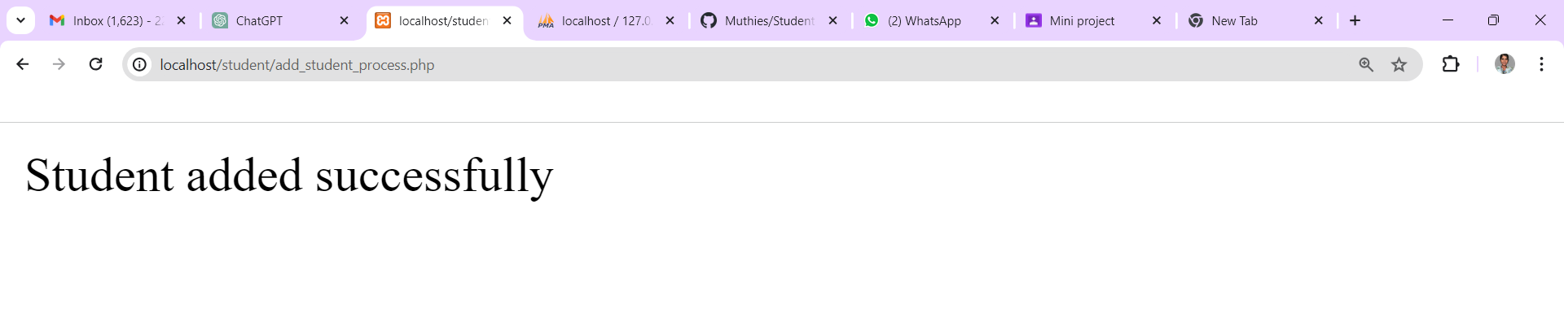
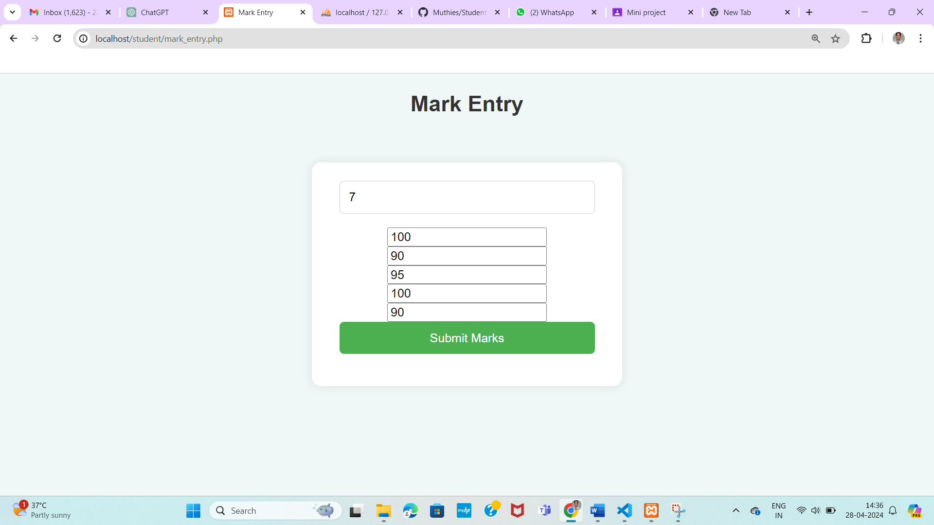
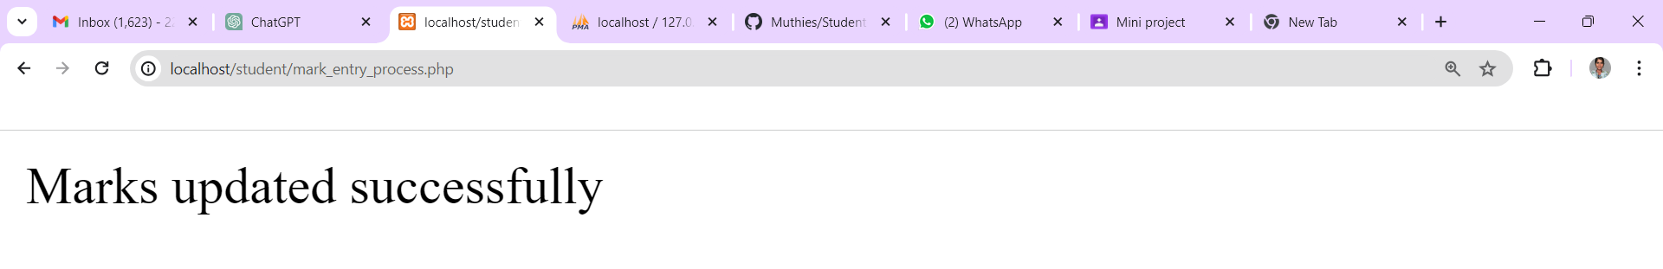
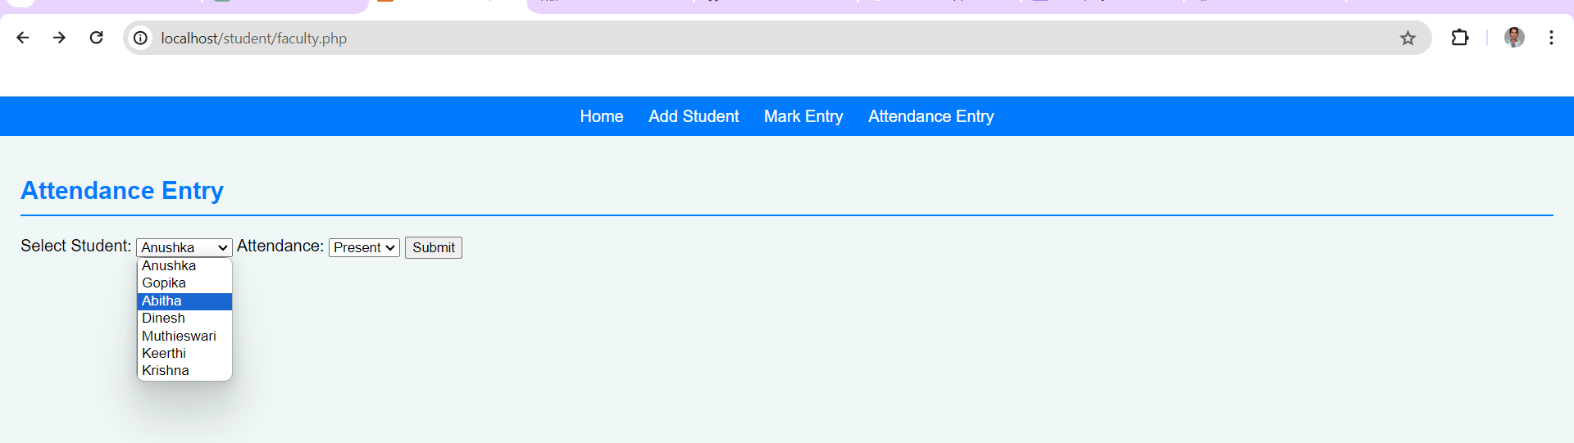
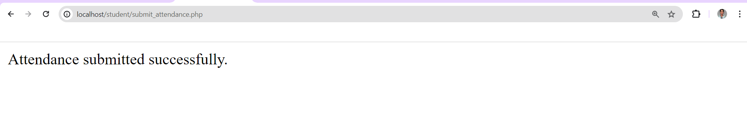
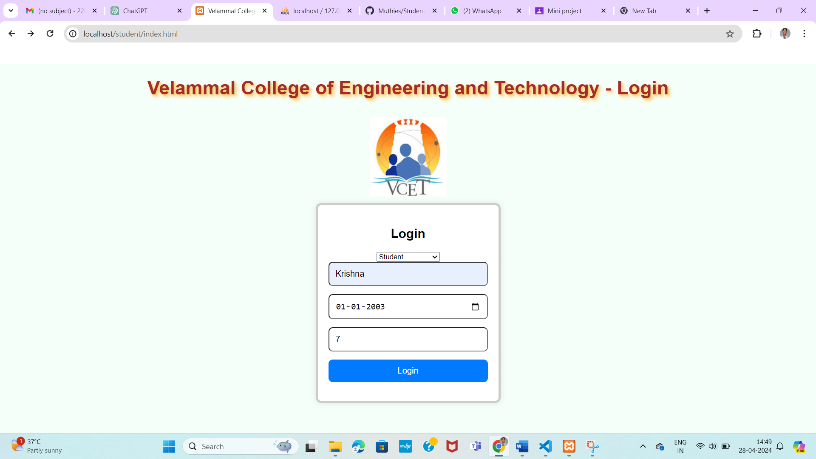
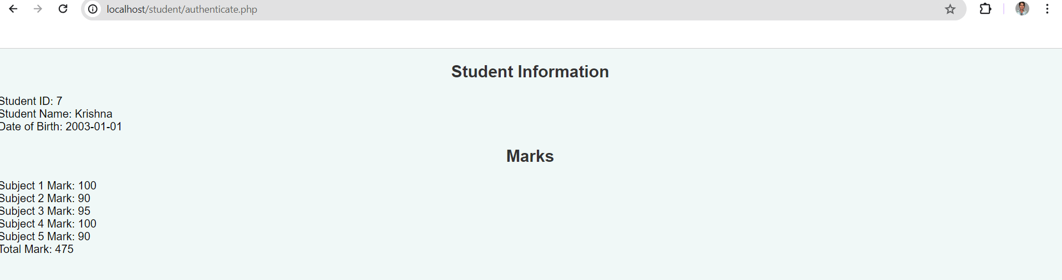

15) CONCLUSION

In conclusion, our project represents a significant milestone in modernizing and enhancing educational institution operations through our student database management system. With its intuitive interface, comprehensive features, and unwavering commitment to data security, our system offers a seamless solution for managing student information. We are proud to present our work as a testament to our dedication to innovation and efficiency in education. Thank you for the opportunity to showcase our project, and we eagerly anticipate its positive impact on educational institutions worldwide. Let our system be the cornerstone of your institution's digital transformation journey, empowering you to achieve greater heights in student management and academic excellence.

16) REFERENCES

1) Database Systems Design, Implementation and Management: By Peter Rob and Carlos Coronel, published by Thomson Learning-Course Technology in 2007
2) Fundamentals of Database Systems: By Elmasri Navathe Pearson Education
3) Github respository: https://github.com/Muthies/Student-database-management-system.git

